Data Analysis Reports
File Name | Row Count | Why the change?
Raw Data | 23,486 | Starting point.
Cleaned Data | 22,628 | Removed 858 rows (14 missing categories + 845 missing Review.Text – 1 overlap). Fixed "Initmates" typo.
Training Data | 21,280 | Removed products with < 5 reviews to solve the "Cold Start" problem.

1. Analysis of Rating Distribution
Graph Reference: rating_distribution.png
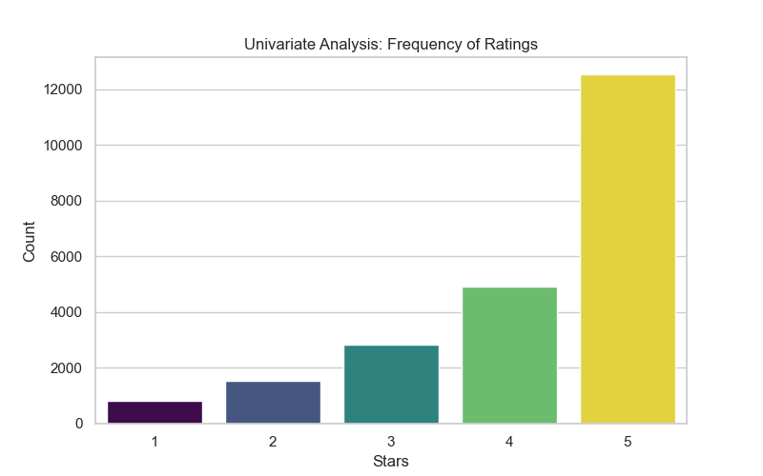
The rating_distribution.png chart visualizes the frequency of each star rating across the dataset. The data reveals that the target variable is heavily weighted toward higher scores, with over 77% of reviews falling into the 4 and 5-star categories. This state is known as Class Imbalance. Because the data is Positively Skewed, relying on a metric like accuracy would be misleading. A model could achieve high accuracy by simply predicting a high rating for every item without actually learning user preferences. To account for this, the project must utilize more robust evaluation metrics such as F1-Score or Precision@K during the modeling phase to ensure the system effectively identifies dissatisfied customers as well as satisfied ones.
2. Categorical and Numerical Variance
Graph Reference: ratings_by_division.png
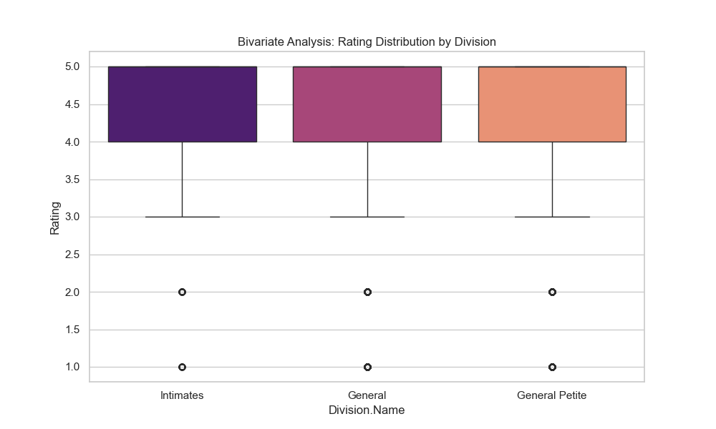
The ratings_by_division.png chart utilizes a boxplot to examine the relationship between product divisions and the ratings they receive. This visualization displays the Interquartile Range and identifies Outliers within each category. The analysis confirms that ratings remain relatively consistent across different sections of the store. Furthermore, it validates that the standardization of the division names was successful. Ensuring that categories like Intimates are unified rather than fragmented by typos allows for consistent Feature Encoding. This stability is essential for the PyTorch model to correctly interpret category-level trends during training.
3. Alignment Between Features and Target
Graph Reference: recommend_probability.png
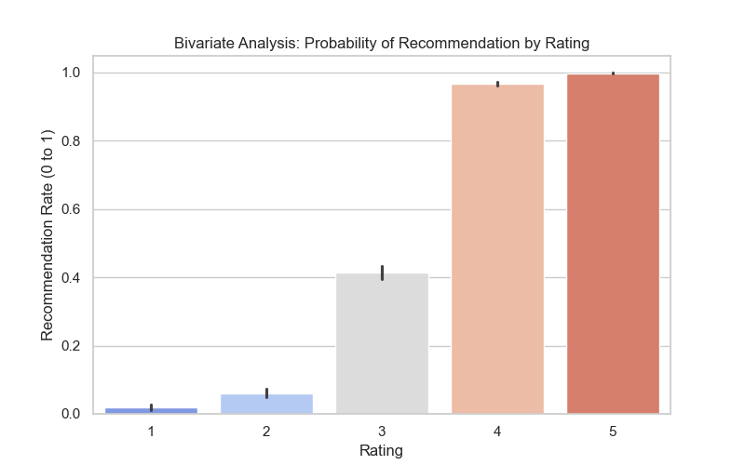
The recommend_probability.png chart evaluates the logical link between the numerical rating a user provides and their binary recommendation (Yes or No). The results show a near-linear correlation between these two variables. This validates the Logical Consistency of the feedback provided by customers. It confirms that the star rating serves as a highly reliable Proxy for overall customer satisfaction. Because this relationship is strong, the star rating can be used as the primary signal for the Loss Function in the deep learning model, providing the algorithm with a clear gradient to follow during optimization.
4. Cold Start and Data Sparsity
Analysis Detail: (Based on review frequency distribution)
The investigation into review frequency per item found that 40.7% of products in the catalog have only a single review. This represents a significant Long Tail Distribution. High Data Sparsity creates a Cold Start Problem, where the system lacks enough interaction history to make reliable predictions for a large portion of the inventory. By establishing a training set that only includes items with at least five reviews, the Signal-to-Noise Ratio has been significantly improved. This ensures that the collaborative filtering logic has enough overlapping data points between different users to generate accurate recommendations.
5. Data Quality and Feature Assessment
Cleaning Summary: (Final Validation)
The preparation phase included a rigorous check for missing information and redundant attributes. Redundant index markers were removed to ensure the model focuses strictly on influential features. To prevent Gradient Instability in the upcoming neural network training, rows missing critical review text were removed. This ensures that every sample fed into the NLP layers contains meaningful content. The final dataset is now structured to support a stable and efficient training process in PyTorch, meeting the engineering standards required for a production-grade recommendation system.

